SAC 4 Item Analysis HMak

Question 1

Using a linear approximation, with $f\left(x\right)=e^{-x}$, then $\frac{1}{e^{0.99}}$ is equal to

A $f\left(1\right)+0.01 f^{'}\left(1\right)$



B $f\left(1\right)-0.01 f^{'}\left(1\right)$

C $f\left(-1\right)+0.01 f^{'}\left(-1\right)$

D $f\left(-1\right)-0.01 f^{'}\left(-1\right)$

E 0.3716

Question 2

If $f\left(x\right)=\frac{x^{2}}{g\left(x\right)}$ and $g\left(3\right)=2$ and $g^{'}\left(3\right)=1$ then $f^{'}\left(3\right)$ is equal to

A $\frac{3}{4}$

B 3

C 6

D 9

E $\frac{-3}{4}$

Question 3

Water is filling a cylinder which has a radius of 5 cm. The height of the water in the cylinder is changing at the variable rate of $\frac{1}{t}$ cm/sec. The rate, in cm3/ sec, at which the volume of the water in the cylinder is changing at t = 10 sec is

A 2π

B 2.5 π

C 25π

D 50π

E 250π

Question 4

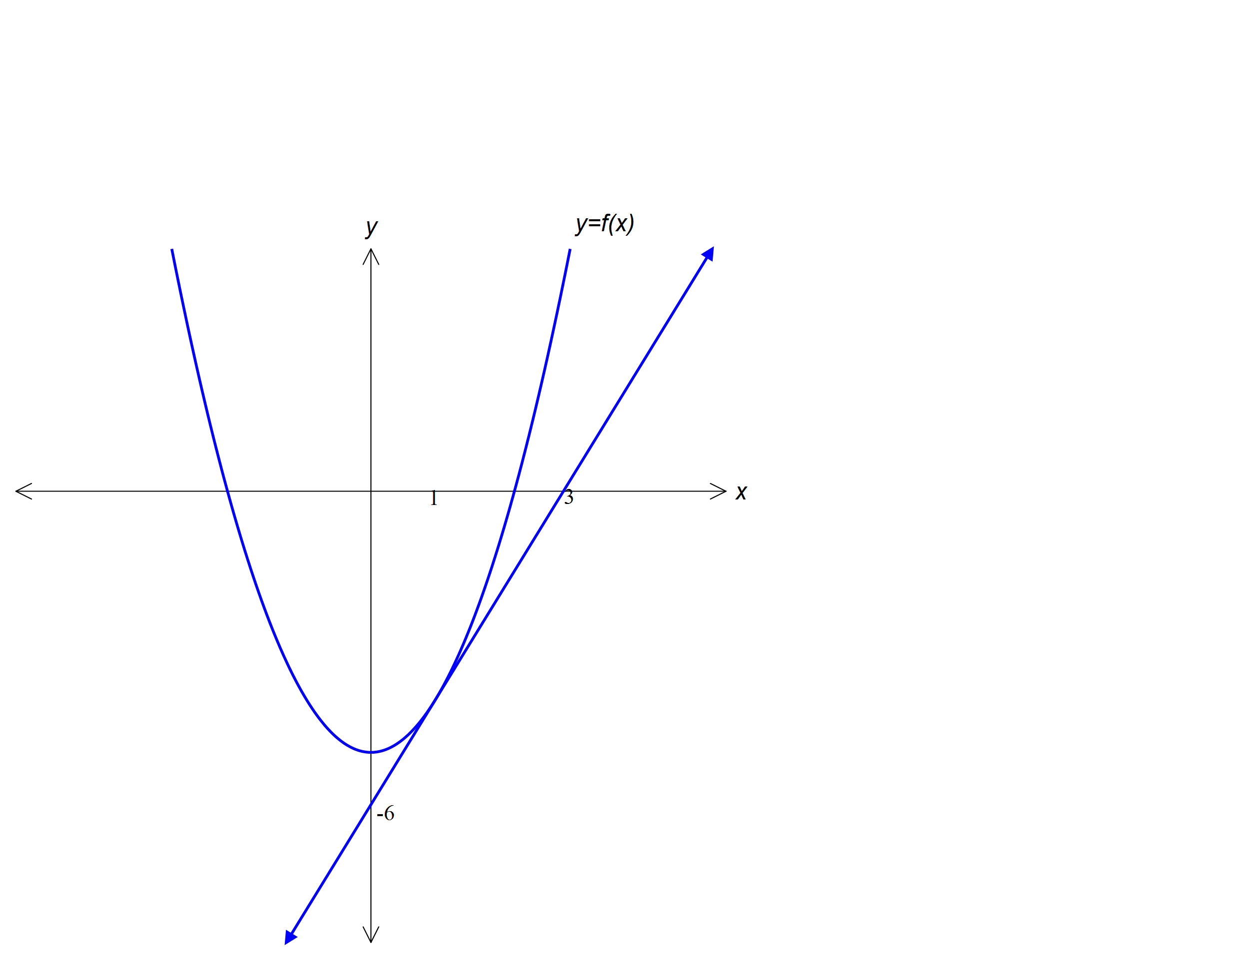

The graph of the function *f*  is shown above. A tangent is drawn to the point where *x* = 1.

It is true to say that

A *f* (1) = 2

B *f* ***´*** (1) = $\frac{1}{2}$

C *f* ***´*** (1) = 2

D *f* (3) = 1

E *f* ***´*** (3) = 0